# **PEEE I Practical Session 2**

Resistor Colour Code & Measuring Resistance

________________________________________________________________________

**1. OBJECTIVES**

* To read the value of a resistor using the colour code.
* To measure resistance using a digital multimeter (DMM) as an ohmmeter.

**2. EQUIPMENT**

* Digital multimeter (DMM).
* Training kit with 100  1.0 k 2.2 k  k  k  k and  k resistors.

**3. INTRODUCTION TO RESISTOR COLOUR CODE**

Most resistors are colour coded with bands of colours. From a colour code, we can know the resistance of a resistor, which may be mounted in any position on a circuit board. The colours of black, brown, red, orange, yellow, green, blue, violet, grey and white represent the numbers from 0 to 9 respectively.

The most common resistor colour code consists of four colour bands. **The first two bands indicate the first two significant digits** of a resistance value. **The third band (multiplier band) indicates the number of zeros following the first two digits.** Gold colour is commonly used for the fourth band to indicate a 5% tolerance value of a resistor.

The colour code is read from the end of a resistor nearer to the first three colour bands. You can refer to Figure 2.1 and Table 2.1 to read the resistance represented by a colour code.

***Tolerance***

***2nd Significant Digit***

### Multiplier

***1st Significant Digit***

Figure 2.1 Resistor Colour Code

|  |  |  |  |  |
| --- | --- | --- | --- | --- |
| **COLOUR** | **FIRST BAND** | **SECOND BAND** | **POWER OF TEN** | **TOLERANCE** |
| ***(1st Significant Digit)*** | ***(2nd Significant Digit)*** | Multiplier |
| Black | 0 | 0 | 100 |  |
| Brown | 1 | 1 | 101 |  |
| Red | 2 | 2 | 102 |  |
| Orange | 3 | 3 | 103 |  |
| Yellow | 4 | 4 | 104 |  |
| Green | 5 | 5 | 105 |  |
| Blue | 6 | 6 | 106 |  |
| Violet | 7 | 7 | 107 |  |
| Grey | 8 | 8 | 108 |  |
| White | 9 | 9 | 109 |  |
| Gold |  |  | 10−1 | 5% |
| Silver |  |  | 10−2 | 10% |
| No Band |  |  |  | 20% |

Table 2.1

For example, if the colours of the 1st significant digit, the 2nd significant digit and the multiplier are yellow, violet and red respectively, the resistance is

*Gold*

*Yellow*

*Violet*

*Red*

Figure 2.2 Example

Yellow (4) Violet (7) × Red (102)

 = 4700  or 4.7 k

If gold is the colour of the tolerance band, the resistance of this resistor is in the range of

4.7 k ±  

= 4.7 k × 0.95) to 4.7 k × 1.05) ≈ **4.47 k to 4.94 k**

**4 PROCEDURE**

4.1 Use the colour code to determine the nominal resistance and the tolerance value of each resistor in Table 2.2, and calculate the minimum and maximum resistances of the resistors.

|  |  |  |  |  |
| --- | --- | --- | --- | --- |
| Resistor on Training Kit | Nominal Resistance (colour code) | Tolerance  (colour code) | Minimum Resistance  (calculate) | Maximum Resistance  (calculate) |
| *R*1 | Ω | % | Ω | Ω |
| *R*A | kΩ | % | kΩ | kΩ |
| *R*B |  |  |  |  |
| *R*C |  |  |  |  |
| *R*D |  |  |  |  |
| *R*E |  |  |  |  |
| *R*F |  |  |  |  |

Table 2.2

HBL note: The colours of the bands for each resistor are given below.

|  |  |  |  |  |
| --- | --- | --- | --- | --- |
| Resistor on Training Kit | **FIRST BAND**  *(1st Significant Digit)* | **SECOND BAND**  (2nd Significant Digit) | **POWER OF TEN**  Multiplier | **TOLERANCE** |
| *R*1 | Brown | Black | Brown | Gold |
| *R*A | Brown | Black | Red | Gold |
| *R*B | Red | Red | Red | Gold |
| *R*C | Yellow | Violet | Red | Gold |
| *R*D | Brown | Black | Orange | Gold |
| *R*E | Yellow | Violet | Orange | Gold |
| *R*F | Brown | Black | Yellow | Gold |

4.2 Measure the resistances of the resistors in Table 2.3 using a digital multimeter (DMM).

4.2.1 Before using the DMM, check whether the **two probes** are correctly connected to the meter for resistance measurement. The black colour probe and the **red** colour probe should be inserted into the DMM **sockets** marked as “**COM”** and “****” respectively.

Figure 2.4

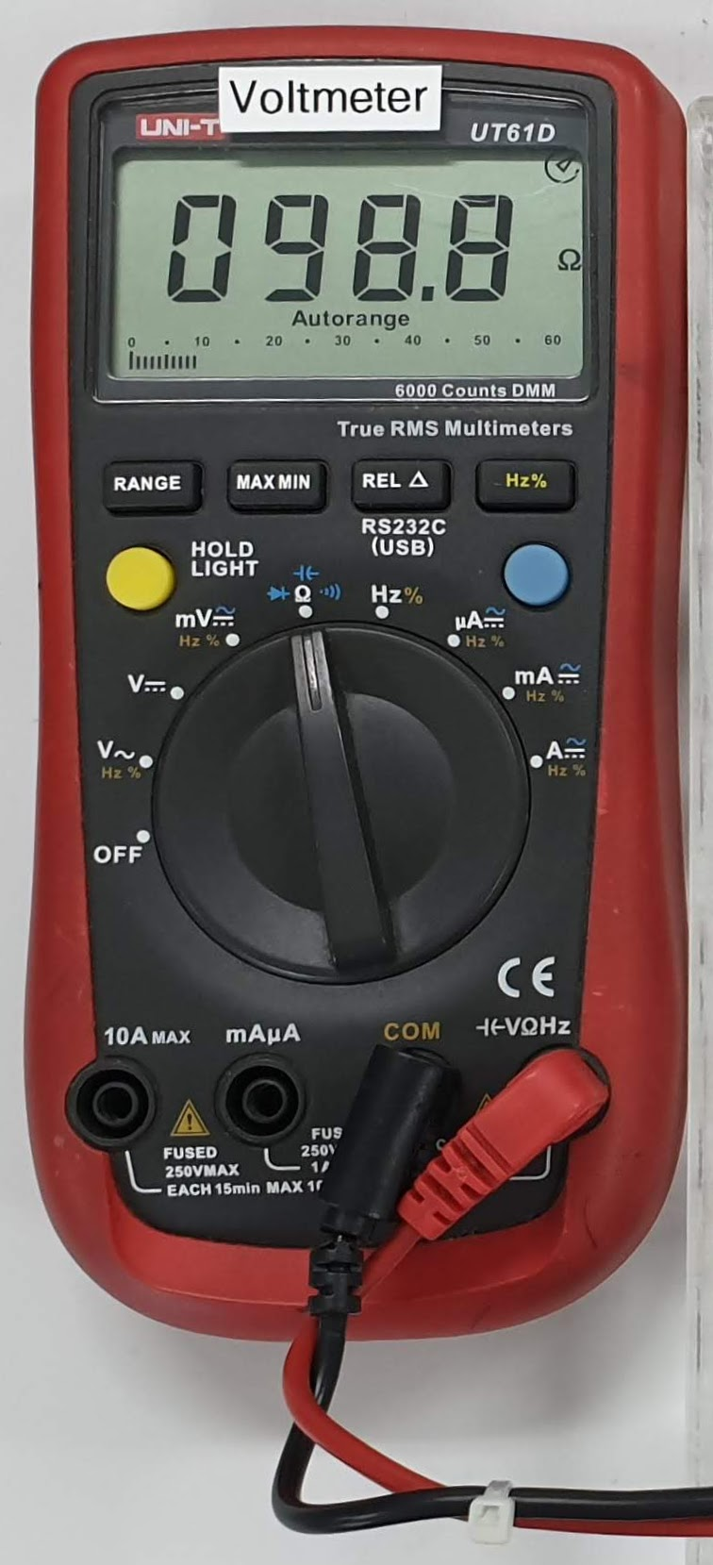

4.2.2 Change the **function** of measurement to “***RESISTANCE***” or “****”.

4.2.3 Connect the other ends of the two probes across resistor *R*1. Record the measured resistance. Write down all the digits.

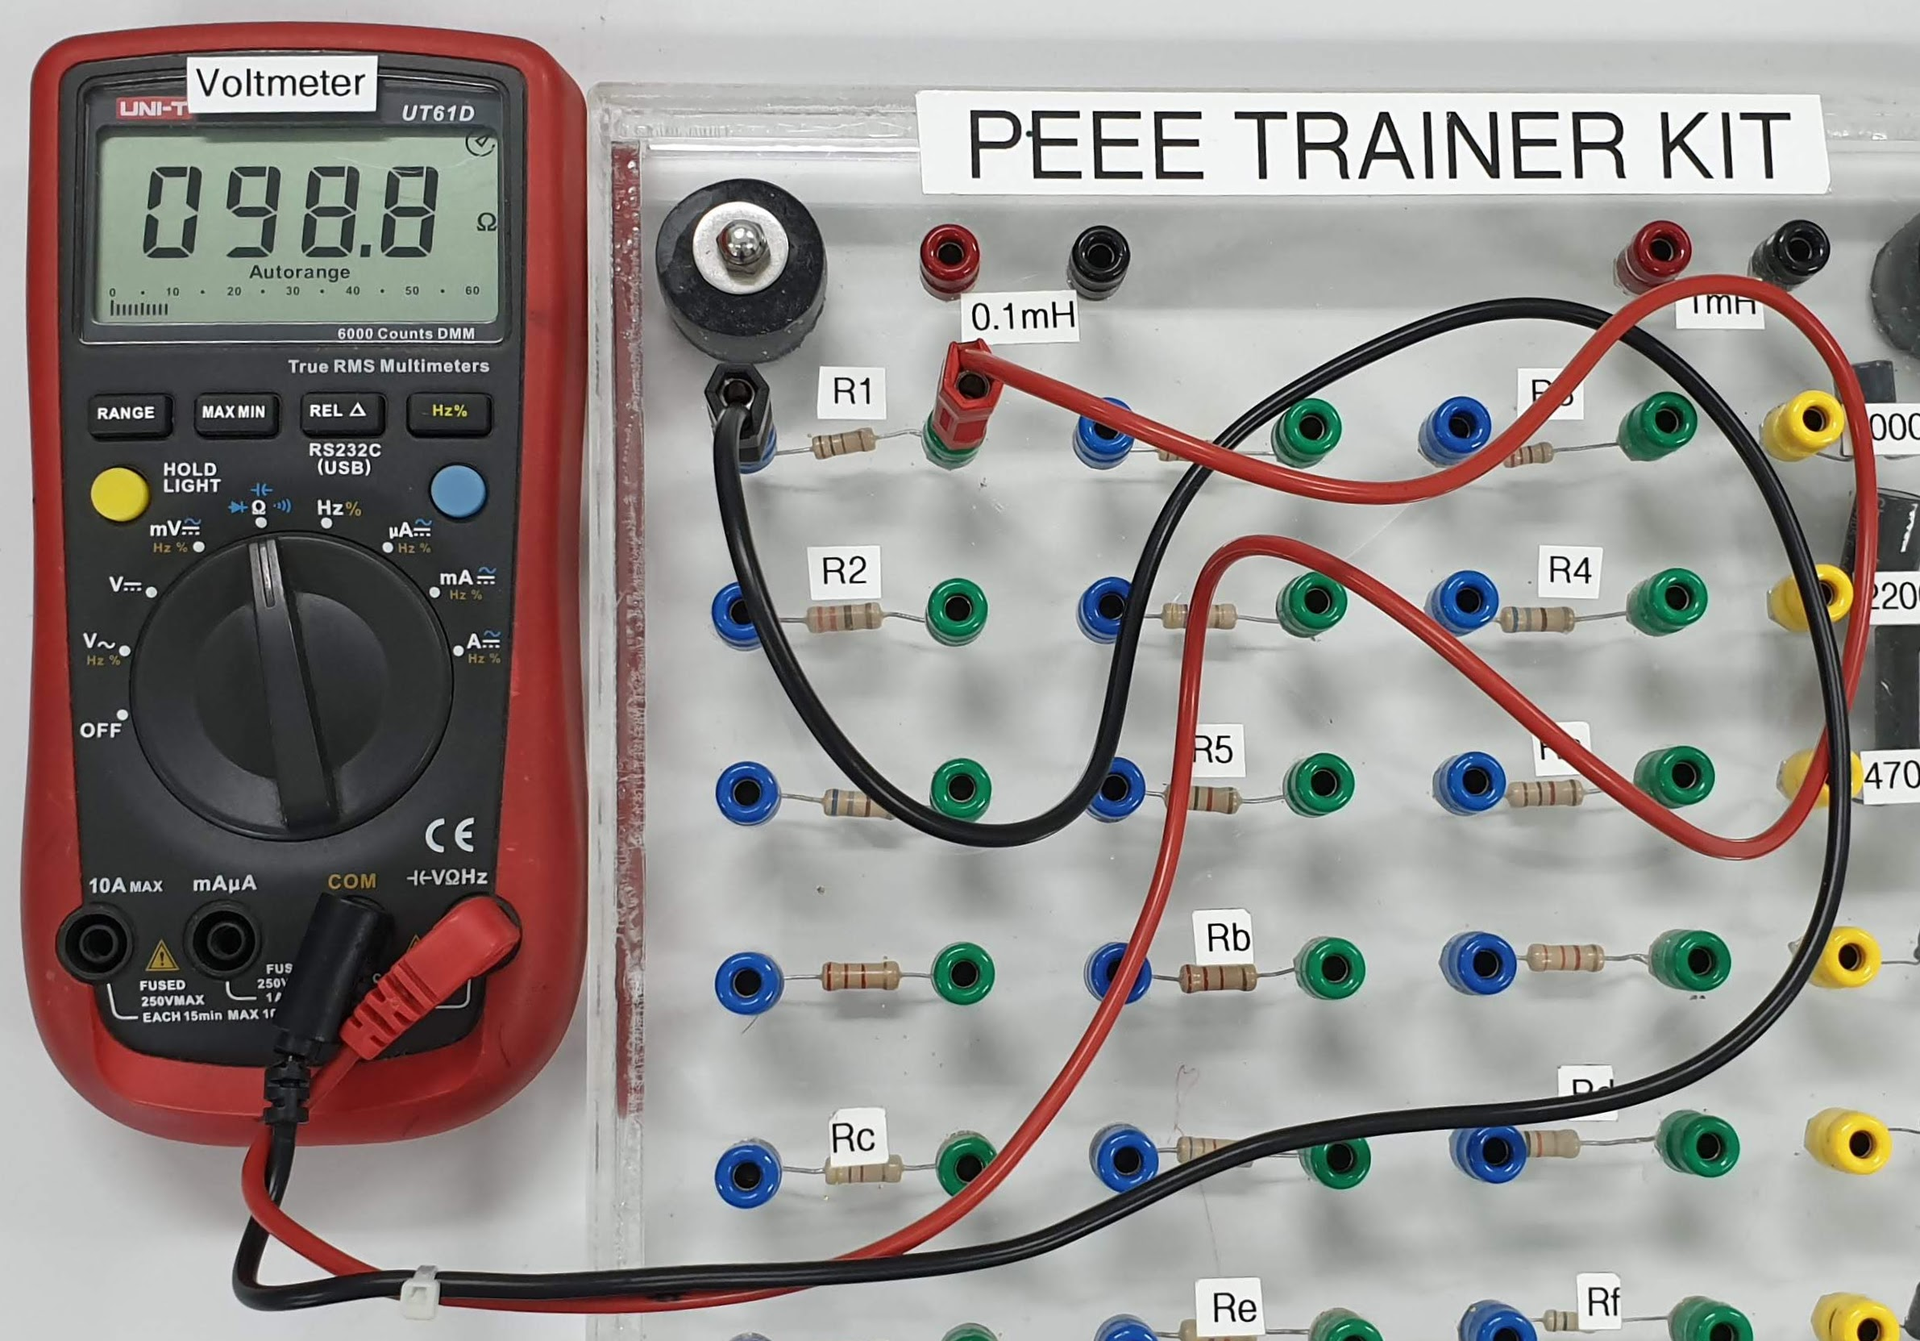

Figure 2.3

4.2.4 Repeat Step 4.2.3 for all other resistors.

|  |  |
| --- | --- |
| Resistor on Training Kit | Measured Resistance  (DMM) |
| *R*1 | *101.0 Ω* |
| *R*A | *0.998 kΩ* |
| *R*B | *2.253 kΩ* |
| *R*C | *4.675 kΩ* |
| *R*D | *10.02 kΩ* |
| *R*E | *48.31 kΩ* |
| *R*F | *98.6 kΩ* |

Table 2.3

HBL note: As you are not able to do this Practical in the lab, please watch the video below.

<https://youtu.be/MMMLiw1Scaw>

The measured resistance have been filled in for you, as shown in Table 2.3.

4.3 Compare and comment on the measured resistance and the nominal resistance.

|  |  |
| --- | --- |
|  | Does each measured resistance (DMM reading) fall within the minimum and maximum resistances in Table 2.2? (Yes/No).  ___________________________________________________________  ___________________________________________________________  ___________________________________________________________ |

**5. CONCLUSION**

_________________________________________________________________________

_________________________________________________________________________

_________________________________________________________________________

_________________________________________________________________________

_________________________________________________________________________